Experiment No. 12
Title: Demonstrate the use of bug tracking and testing tool Bugzilla and Jira
Bugzilla
Selecting Issue Type and Entering Bug Summary for Amazon Website in Webcompat (Bugzilla)
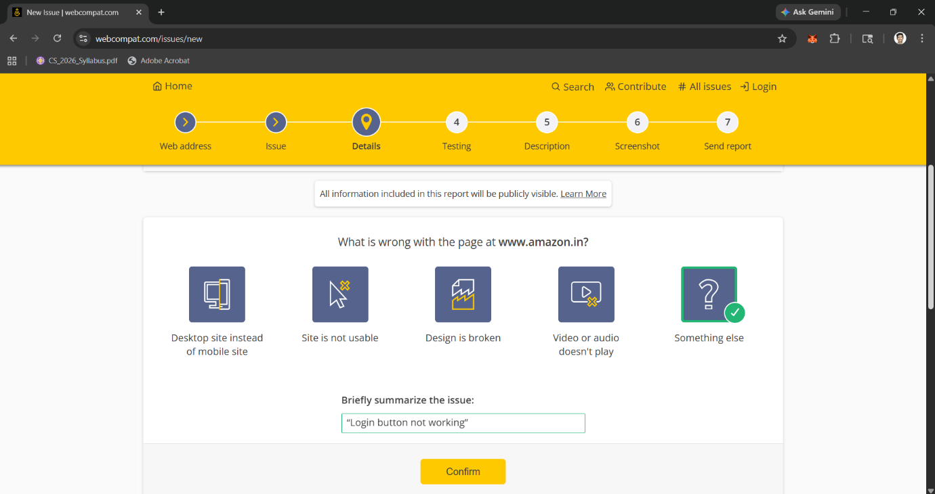

Confirming Device and Browser Details for Bug Reproduction
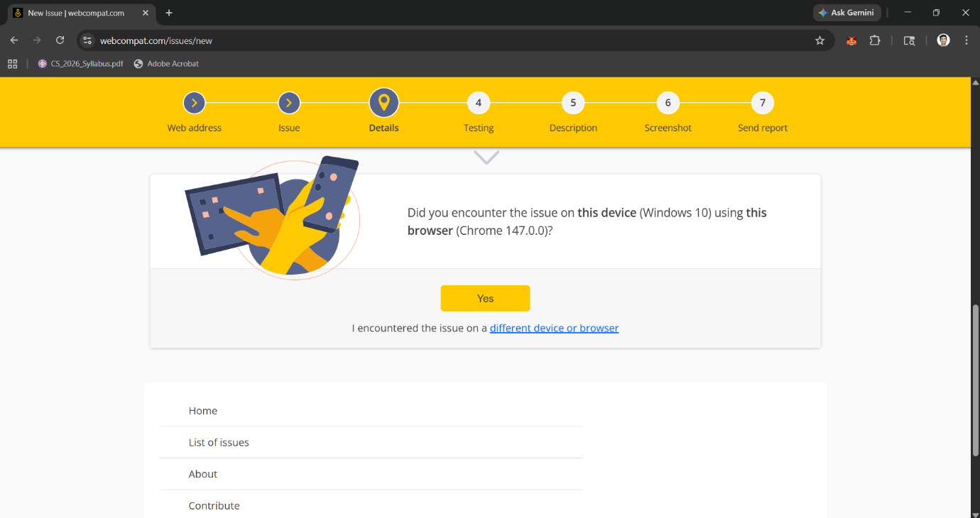

Providing Detailed Description of the Bug (Add to Cart not working)
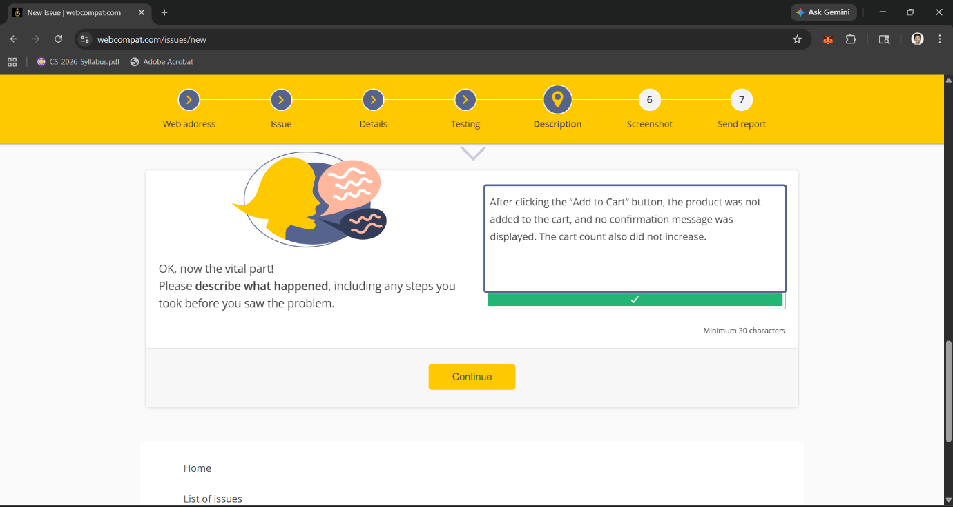

Submitting the Bug Report Successfully via Webcompat Platform
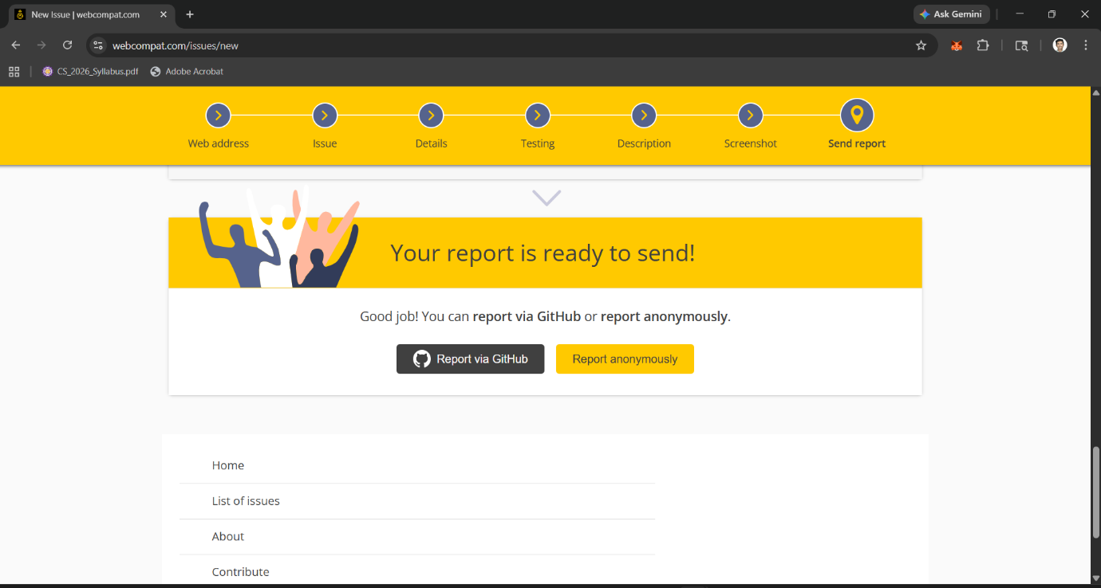

Bug Report Successfully Created with Issue ID and Status in Moderation Queue
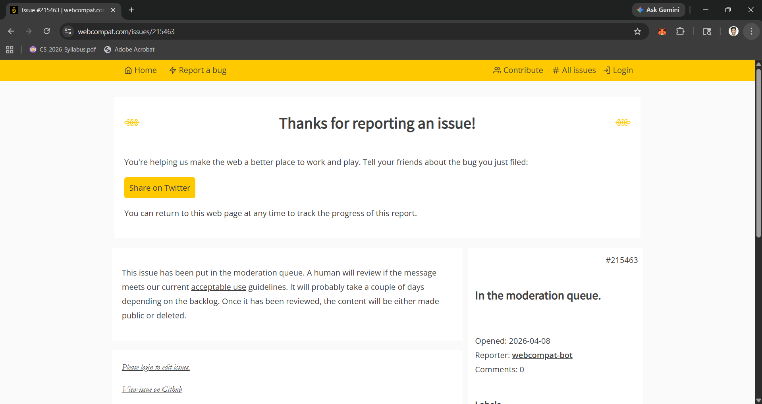

Accessing Bugzilla Main Dashboard for Bug Tracking and Management
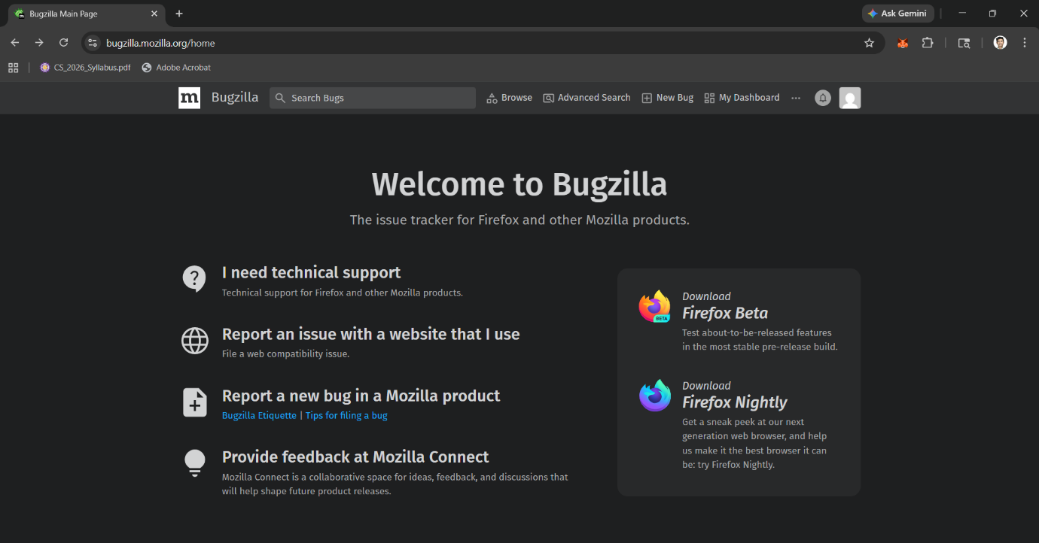
Result: Bug was successfully reported, documented, and tracked using Bugzilla (Webcompat) tool.

Jira
Selection of Kanban Template in Jira for Project Creation
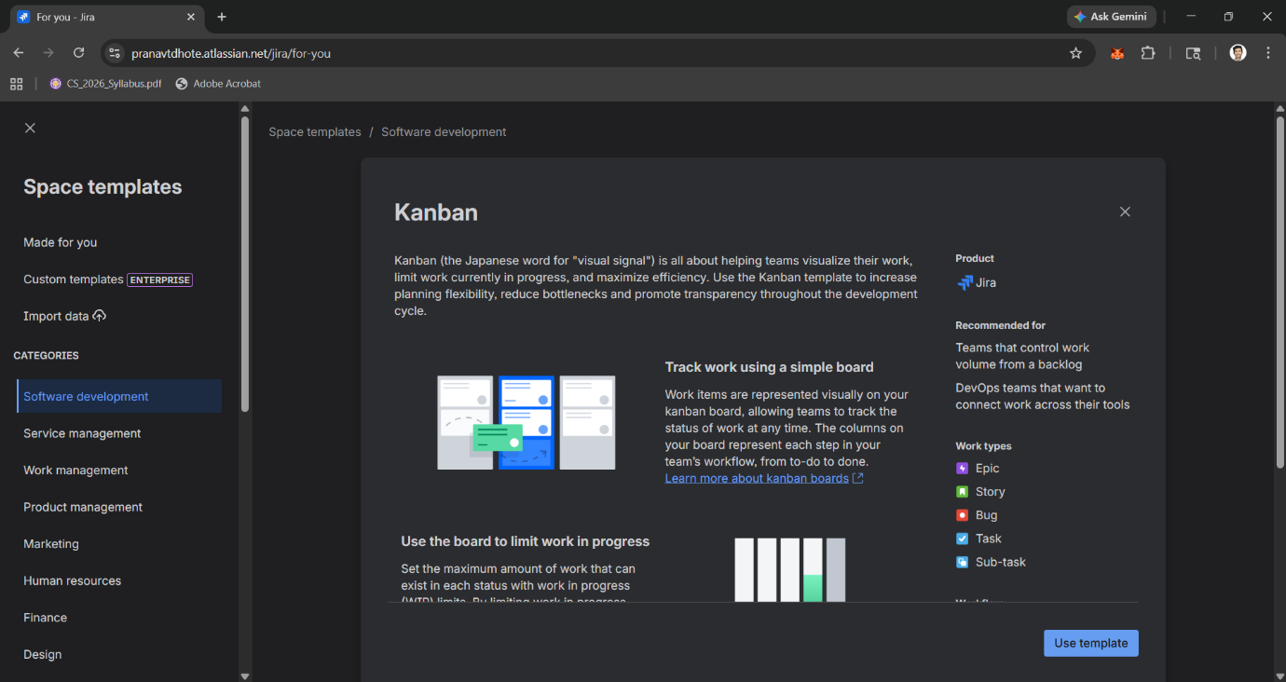

Creating New Project “Amazon Testing” in Jira
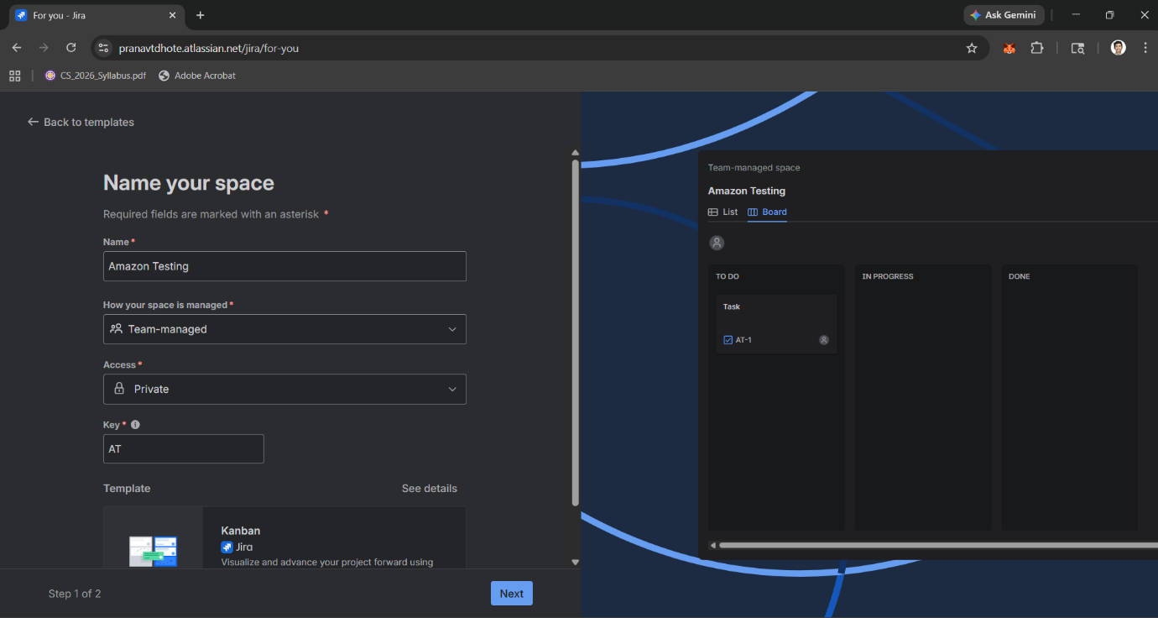

Creating a Bug Issue in Jira (Add to Cart not working)
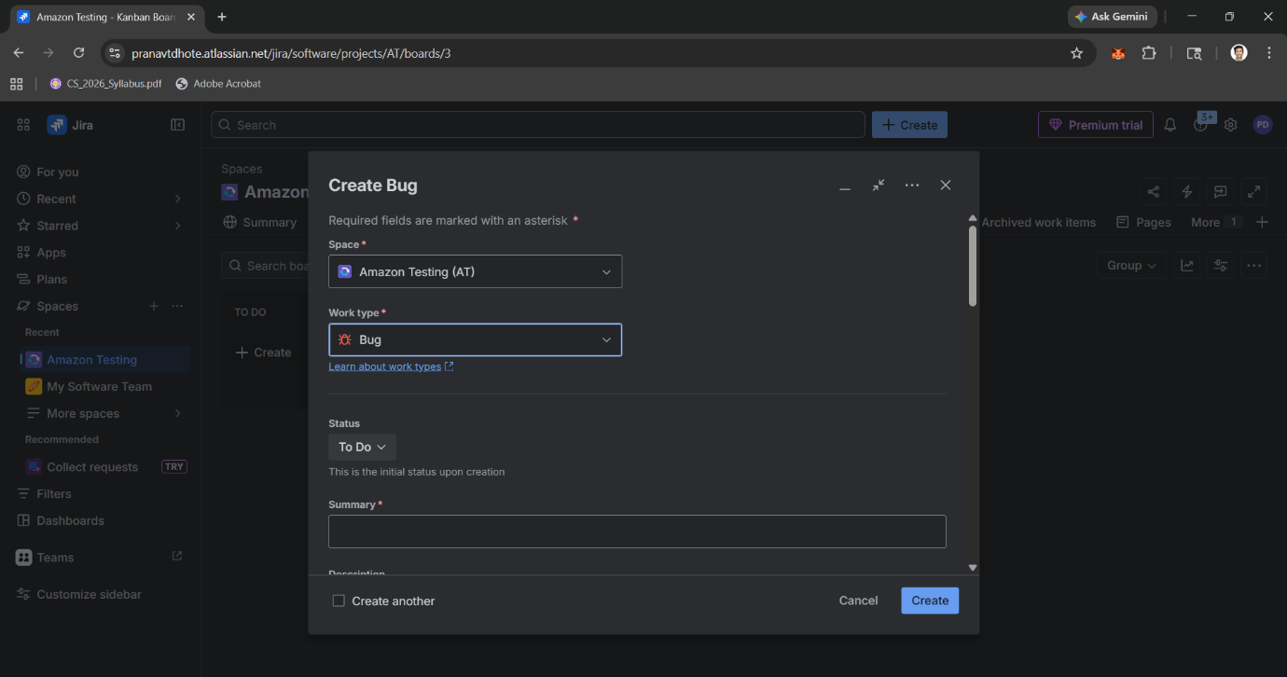

Viewing Bug Details in Jira with Description and Assigned User
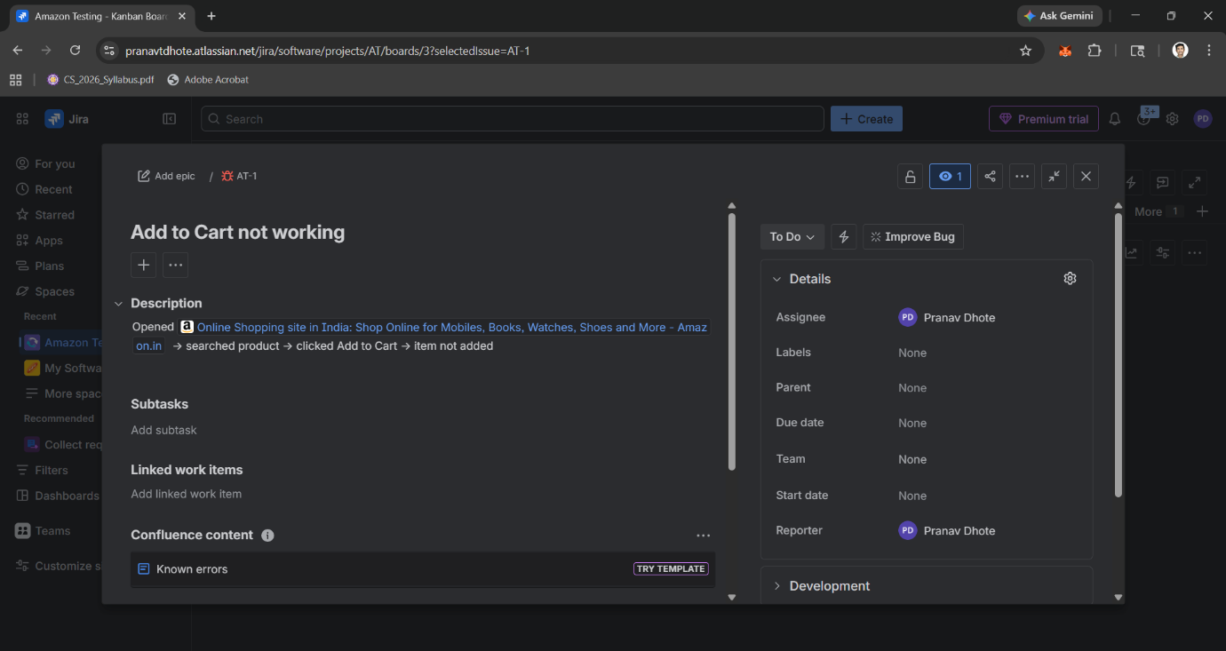

Bug Successfully Moved Across Workflow (To Do → Done) in Jira Board
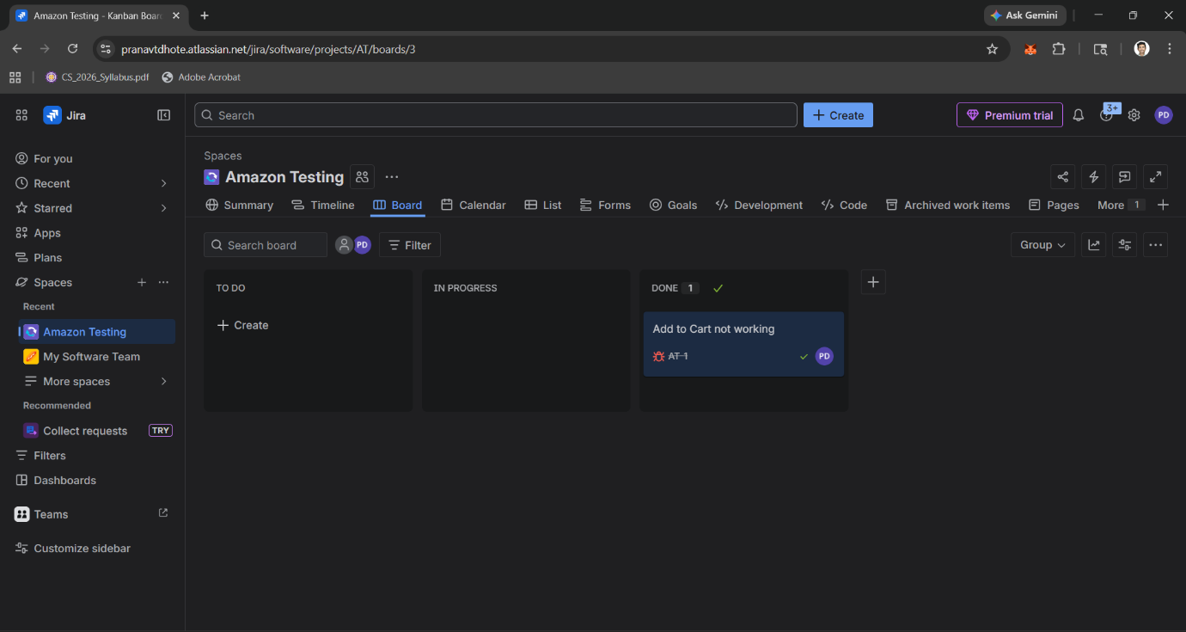
Result: Bug was successfully created, assigned, and tracked in Jira using Kanban workflow.

